CSIT314 Software Development Methodologies - Group Project

Sprint 3 - US20: Add current IDP
Interior Design Platform - Interior Designer
All diagrams were drawn in draw.io. Open "US20 Add current IDP.drawio" in this folder to edit them - each diagram is its own page in that file. The exported images are in the "diagrams" folder.

Assumptions
- The system is the Interior Design Platform from the project specification. Sprint 3 covers the Interior Designer's current IDP stories (add, view, update, delete and search, US20 - US24) and the Customer's log in, IDP search, IDP view and log out stories (US30 - US32, US36).
- We follow B-C-E: the actor only talks to the boundary (page), the boundary only talks to the controller, and the controller works with the entity classes. There is one controller per use case.
- The boundary checks all the input (required fields, lengths, formats, e.g. not suspending your own profile) and trims spaces, then passes an entity object on. The controller just calls the entity and returns the result. The entity checks for duplicates and the database state (e.g. name already used, only Active rows are changed), then saves. In US20 the page trims the input, puts it in an IDP object and checks every field rule itself; the controller just calls add; the entity only inserts the IDP if its category is still Active.
- An IDP is an interior design project. A current IDP is one the designer is still working on (US20 - US24); a past IDP is a completed one (US25 onwards). Both are rows in the idp table with projectType Current or Past.
- Logged in as an interior designer (UC13) is the precondition. designerLoginRequired in app.py only sends someone with no session to /designer/login; the use case doesn't check the designer again (no InteriorDesignerLoginController).
- The form has a project title (required, 3-100 characters), an IDP category (required), a description (required, up to 2000) and a location (optional, up to 200).
- The category drop-down only lists Active IDP categories made by the Platform Manager (US41). Listing the categories is US45's job, so the page borrows SearchIDPCategoryController (empty keyword) and keeps the Active ones - the same way US8 borrows the US7 controller for its profile drop-down. A category that is Suspended (US44) can't be chosen, even by posting its id: the page rejects it, and the entity only saves the IDP if the category is still Active.
- The owner (designerId) is always the logged-in designer from the session, never a form field.
- A new IDP is saved as projectType Current and status Active, and appears under its category for the Platform Manager (US42). Viewing, updating, deleting and searching current IDPs are US21 - US24.
- Photos are not part of this story.

1. User story
Story ID | US20
User story | As an interior designer, I want to add a current IDP so that I can show customers what I am working on.
Actor | Interior Designer
Priority | High
Story points (estimate) | 3
Acceptance criteria | 1. Given I am on the designer dashboard, the Current IDPs card has an "Add current IDP" button that opens the form.  2. The form has project title, IDP category, project description and location. The first three are required.  3. The IDP category drop-down only shows Active categories.  4. Given I fill in the form correctly and click "Add current IDP", then the IDP is saved as a current IDP owned by me, I go back to the dashboard and see "Current IDP added successfully".  5. Given a required field is empty, a field is too long or no available category is chosen, then I see "Please fix the highlighted fields", what I typed is kept and nothing is saved.  6. Given there are no Active categories, then I see "No IDP categories are available yet. Please try again later".
Tasks | T20.1 Write the use case description and draw the use case diagram  T20.2 Draw the B-C-E class diagram and the sequence diagram  T20.3 Draw the wireframes for the dashboard button, the form, the form errors, the success message and no categories  T20.4 Add the idp table to database/schema.sql  T20.5 Write the unit tests first (TDD) for IDP, AddCurrentIDPController and AddCurrentIDPPage  T20.6 Code IDP.addCurrentIDP() (only saves when the category is still Active)  T20.7 Code AddCurrentIDPController (just calls add)  T20.8 Code AddCurrentIDPPage (field rules and the category drop-down), the form template and the dashboard button  T20.9 Run the test cases, fix bugs and push to the repo so the CI pipeline runs the unit tests

2. Use case diagram
The user story becomes one use case, UC20 Add current IDP. The Interior Designer is the only actor.
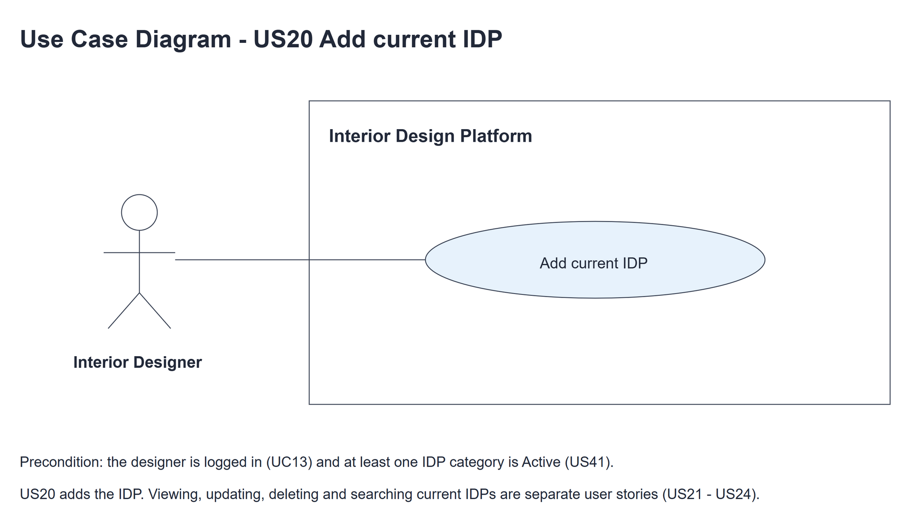
Figure 1: Use case diagram for US20 Add current IDP

3. Use case description
Use case | UC20 Add current IDP
Actor | Interior Designer
Brief description | The Interior Designer adds a project they are working on, so customers can see it.
User story | US20: As an interior designer, I want to add a current IDP so that I can show customers what I am working on.
Preconditions | The Interior Designer is logged in (UC13). designerLoginRequired in app.py only sends someone with no session to /designer/login.
Trigger | The Interior Designer clicks "Add current IDP" on the dashboard.
Basic flow | 1. The Interior Designer clicks "Add current IDP".  2. The system shows the form with the Active IDP categories.  3. The Interior Designer fills in the project details, chooses a category and clicks "Add current IDP".  4. The system checks the fields (required fields, lengths and that the category is one of the Active ones).  5. The system saves the IDP as a Current, Active IDP with the logged-in designer as the owner.  6. The system shows the designer dashboard with "Current IDP added successfully".
Alternative flows | 2a. There are no Active IDP categories: the system shows "No IDP categories are available yet. Please try again later" instead of the form. The use case ends.  3a. The Interior Designer clicks "Cancel": the system goes back to the dashboard and nothing is saved.  4a. A field is wrong (including a category that was suspended meanwhile): the system shows "Please fix the highlighted fields", highlights the wrong fields and keeps what was typed. Back to step 3.  5a. The save fails (e.g. the category was suspended between steps 4 and 5): the system shows "Current IDP could not be added. Please try again". Back to step 3.
Postconditions | A new current IDP is saved, owned by the designer and linked to an Active category.  The Platform Manager sees it in that category (US42).

4. Wireframes
The wireframes were drawn in draw.io. They are low-fidelity: they show the layout and the flow, not the final colours. The orange numbers match the notes under each screen.

4a - Add button
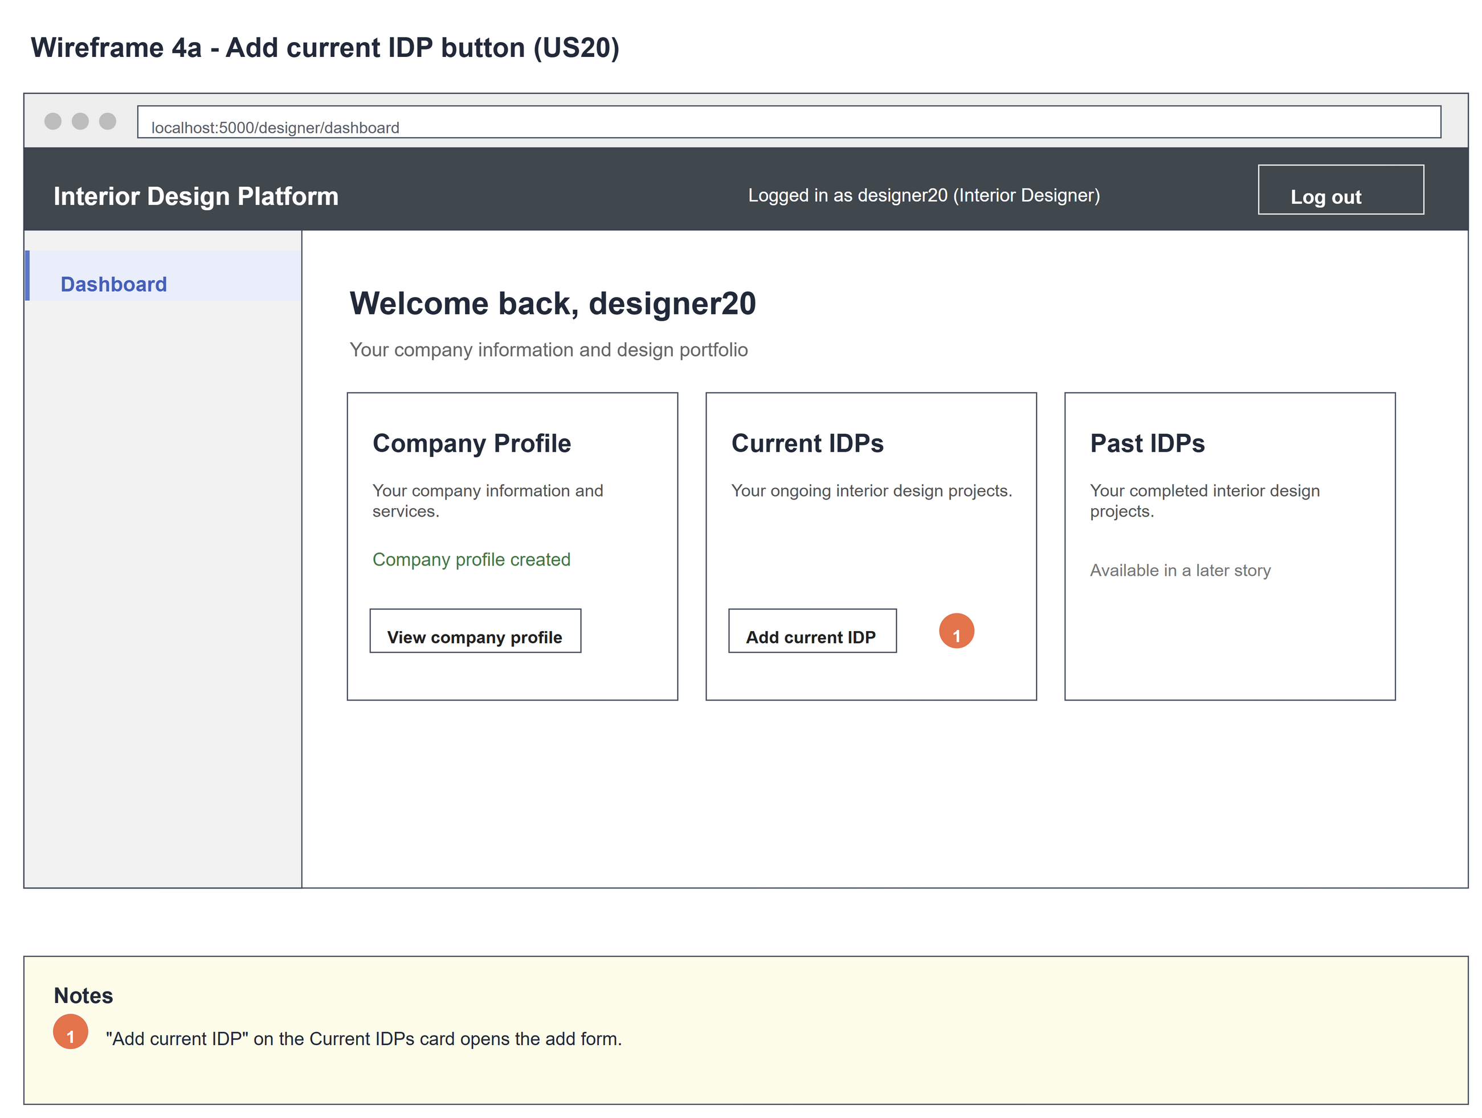
Figure 2: Wireframe 4a - Add button (US20)

4b - Add form
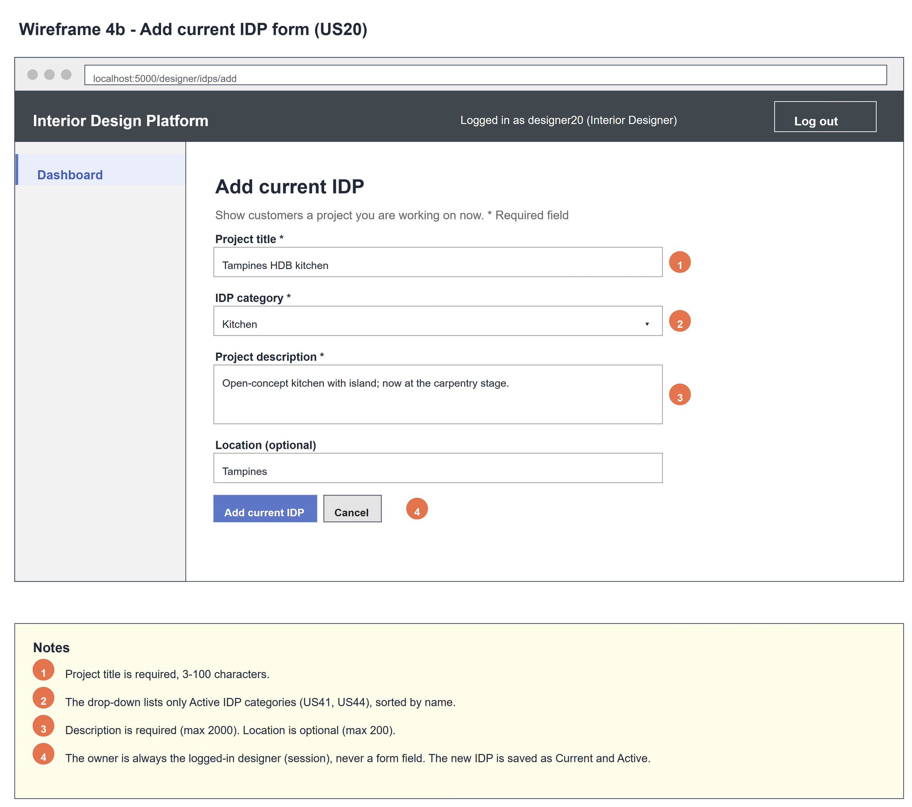
Figure 3: Wireframe 4b - Add form (US20)

4c - Form errors
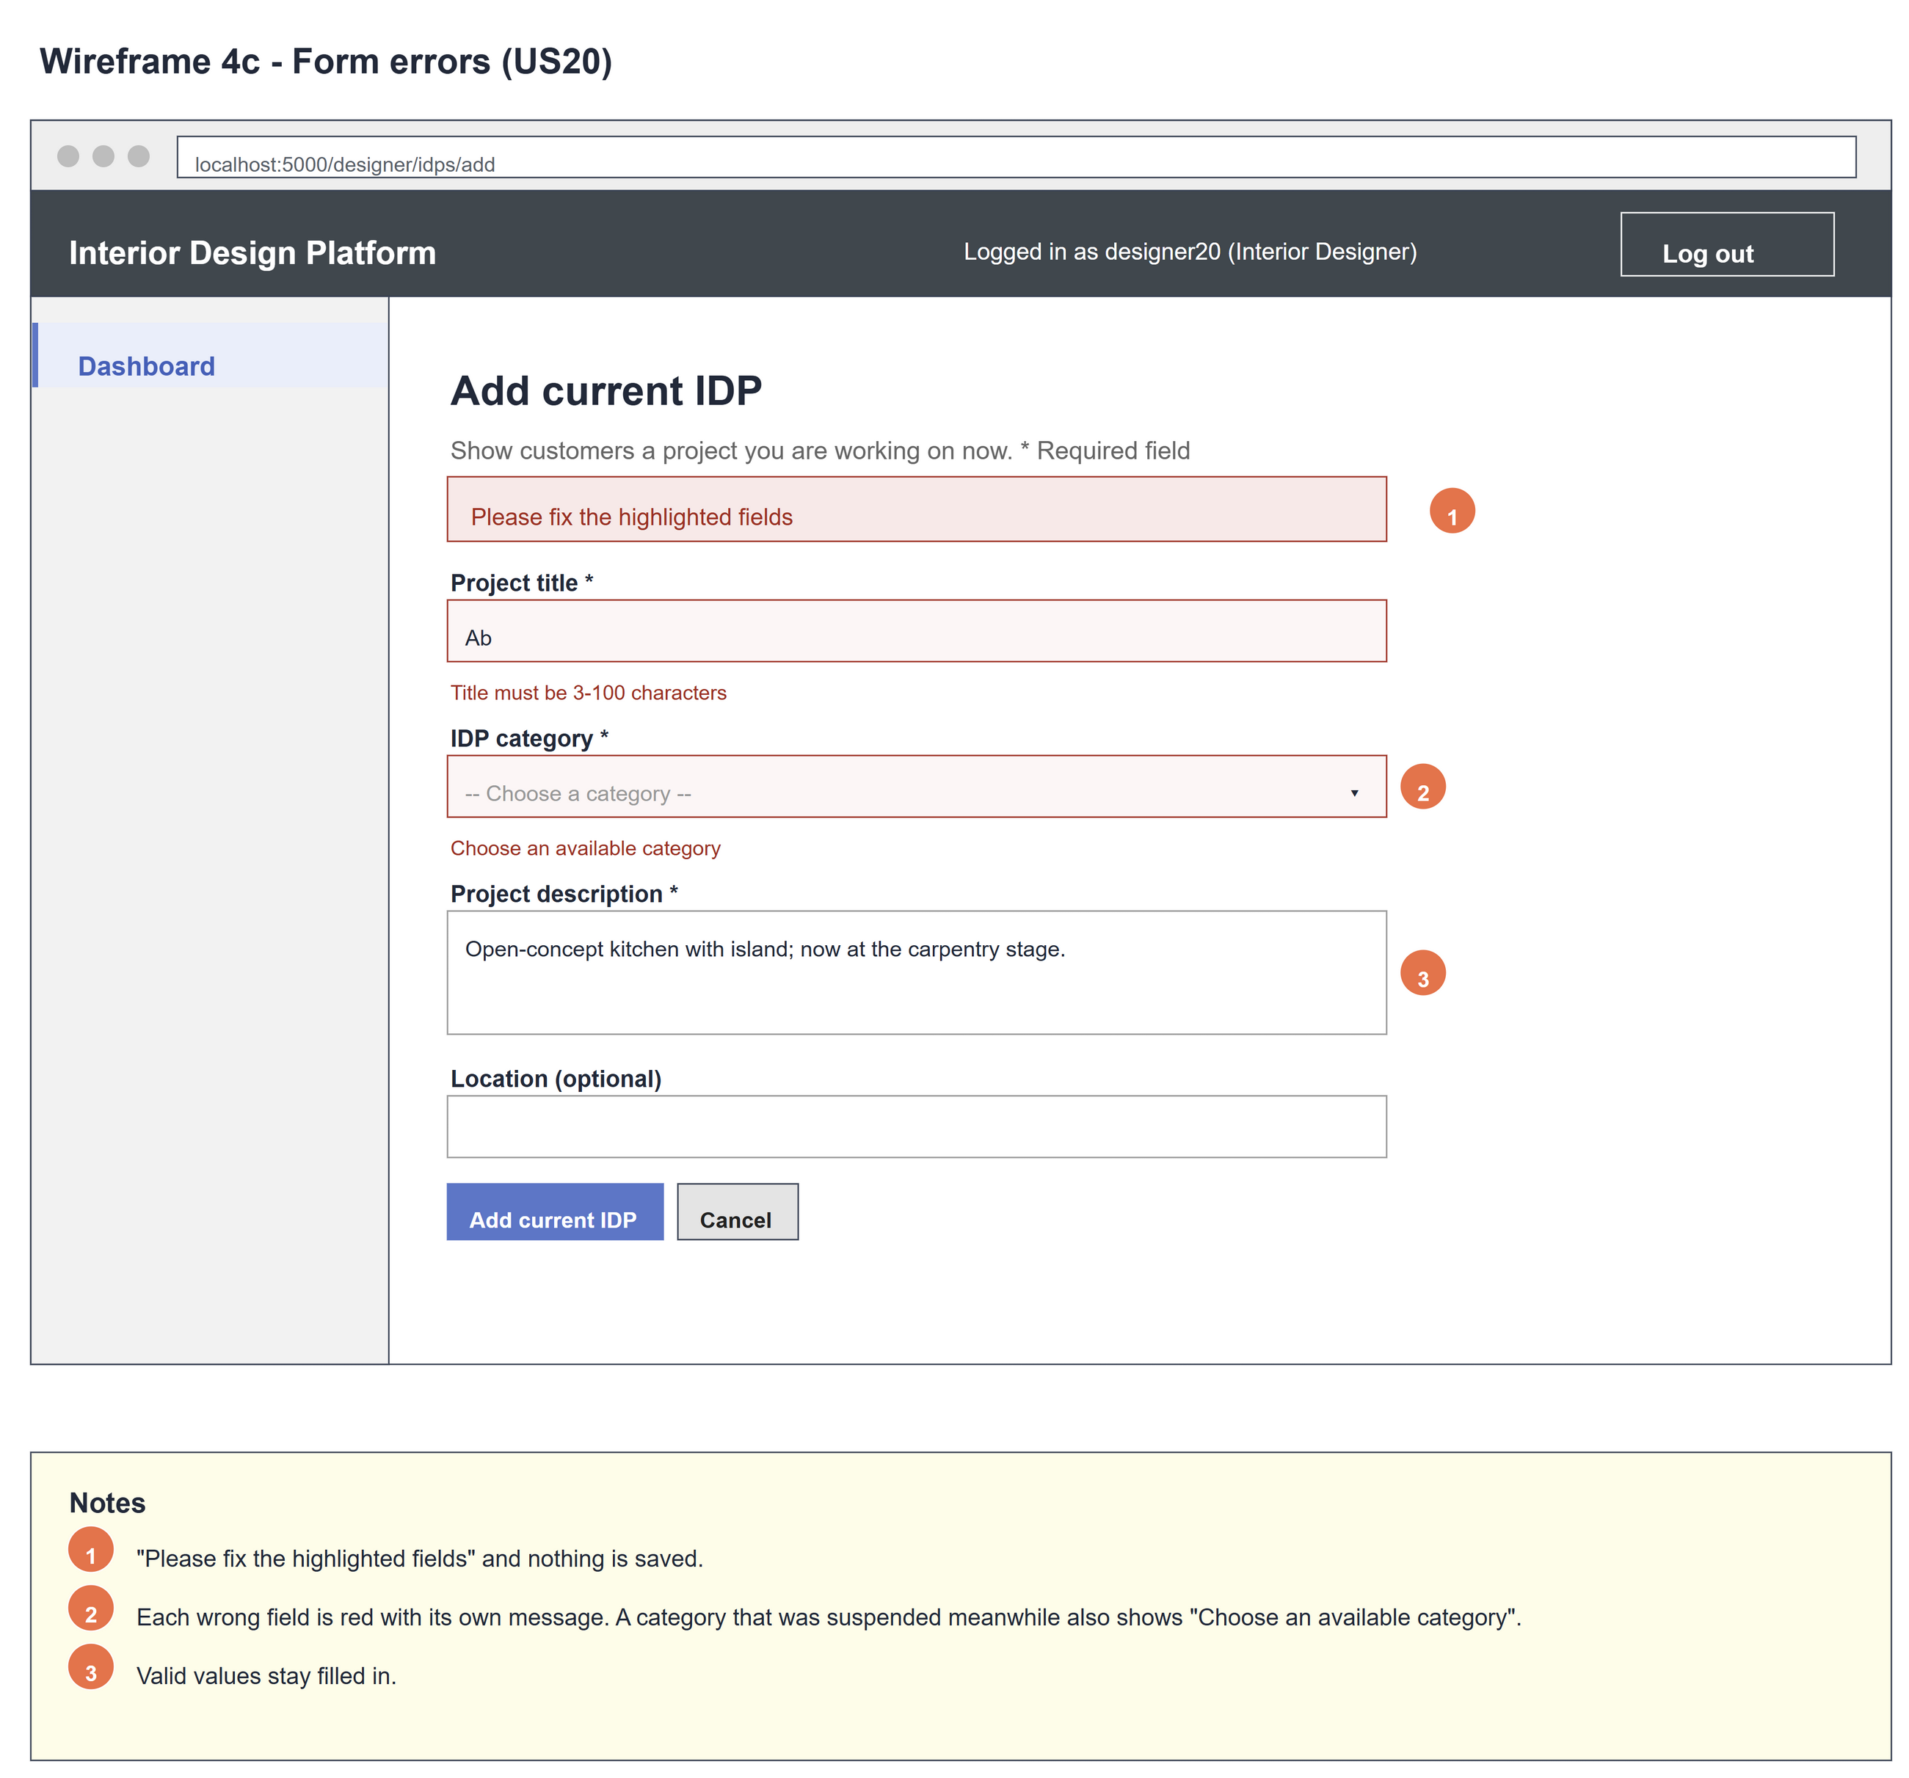
Figure 4: Wireframe 4c - Form errors (US20)

4d - IDP added
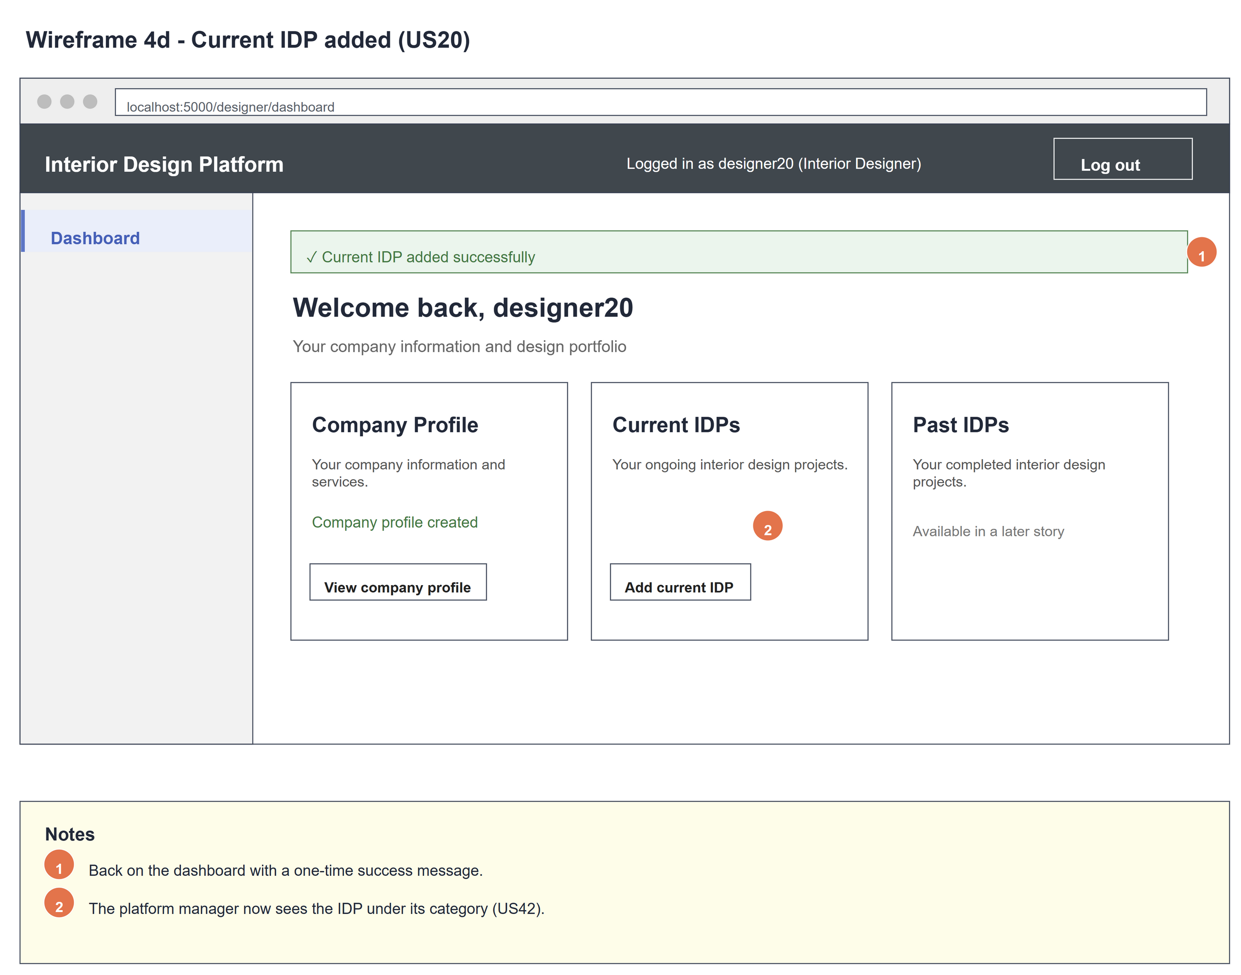
Figure 5: Wireframe 4d - IDP added (US20)

4e - No categories yet
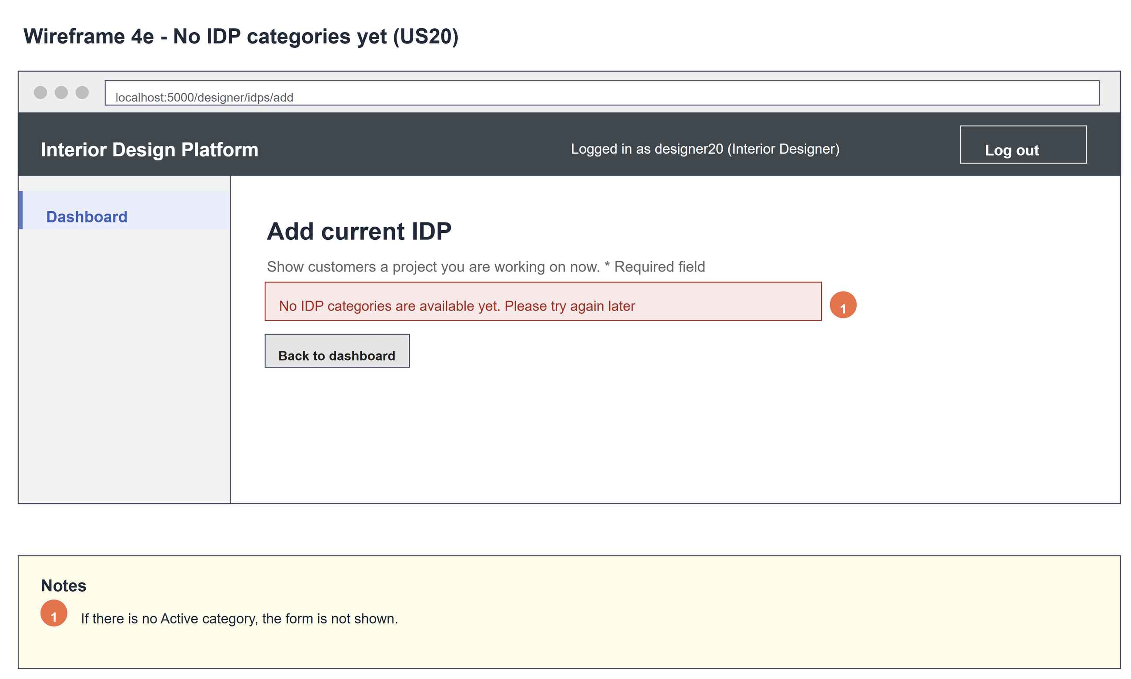
Figure 6: Wireframe 4e - No categories yet (US20)

5. B-C-E class diagram
The solid line means the boundary calls the controller. The dashed lines mean the controller uses the other classes. Only the operations needed for this use case are shown, with the same names as the code.
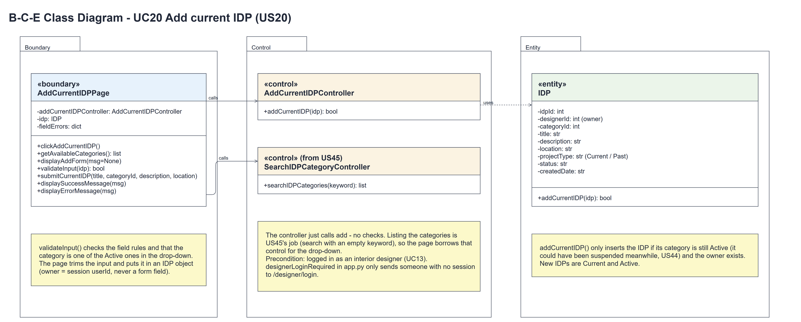
Figure 7: B-C-E class diagram for US20 Add current IDP
Layer | Class | What it does
Boundary | AddCurrentIDPPage | The add form. getAvailableCategories() fills the drop-down, submitCurrentIDP() trims the input and puts it in an IDP object (owner = session userId), validateInput() checks the fields and the category, then the page calls the controller and shows displaySuccessMessage() or displayErrorMessage().
Control | AddCurrentIDPController | Controller for UC20. addCurrentIDP(idp) just calls the entity and returns the result - no checks.
Control | SearchIDPCategoryController (from US45) | searchIDPCategories("") lists every category; the page keeps the Active ones for the drop-down.
Entity | IDP | The only entity. One row of idp. addCurrentIDP() inserts a Current, Active IDP only if the category is still Active and the owner exists.

6. Sequence diagram
The sequence diagram follows UC20. Opening the form borrows the US45 controller to list the categories and keeps the Active ones; the first alt shows the form, or the "no categories" message (2a). On submit the page trims the input, puts it in an IDP and validates it - validateInput() borrows the categories again to check the chosen one (step 4). The outer alt saves when the input is valid (the controller just calls the entity); the inner alt shows the success redirect (step 6) or the save error (5a). Invalid input shows the field errors (4a).
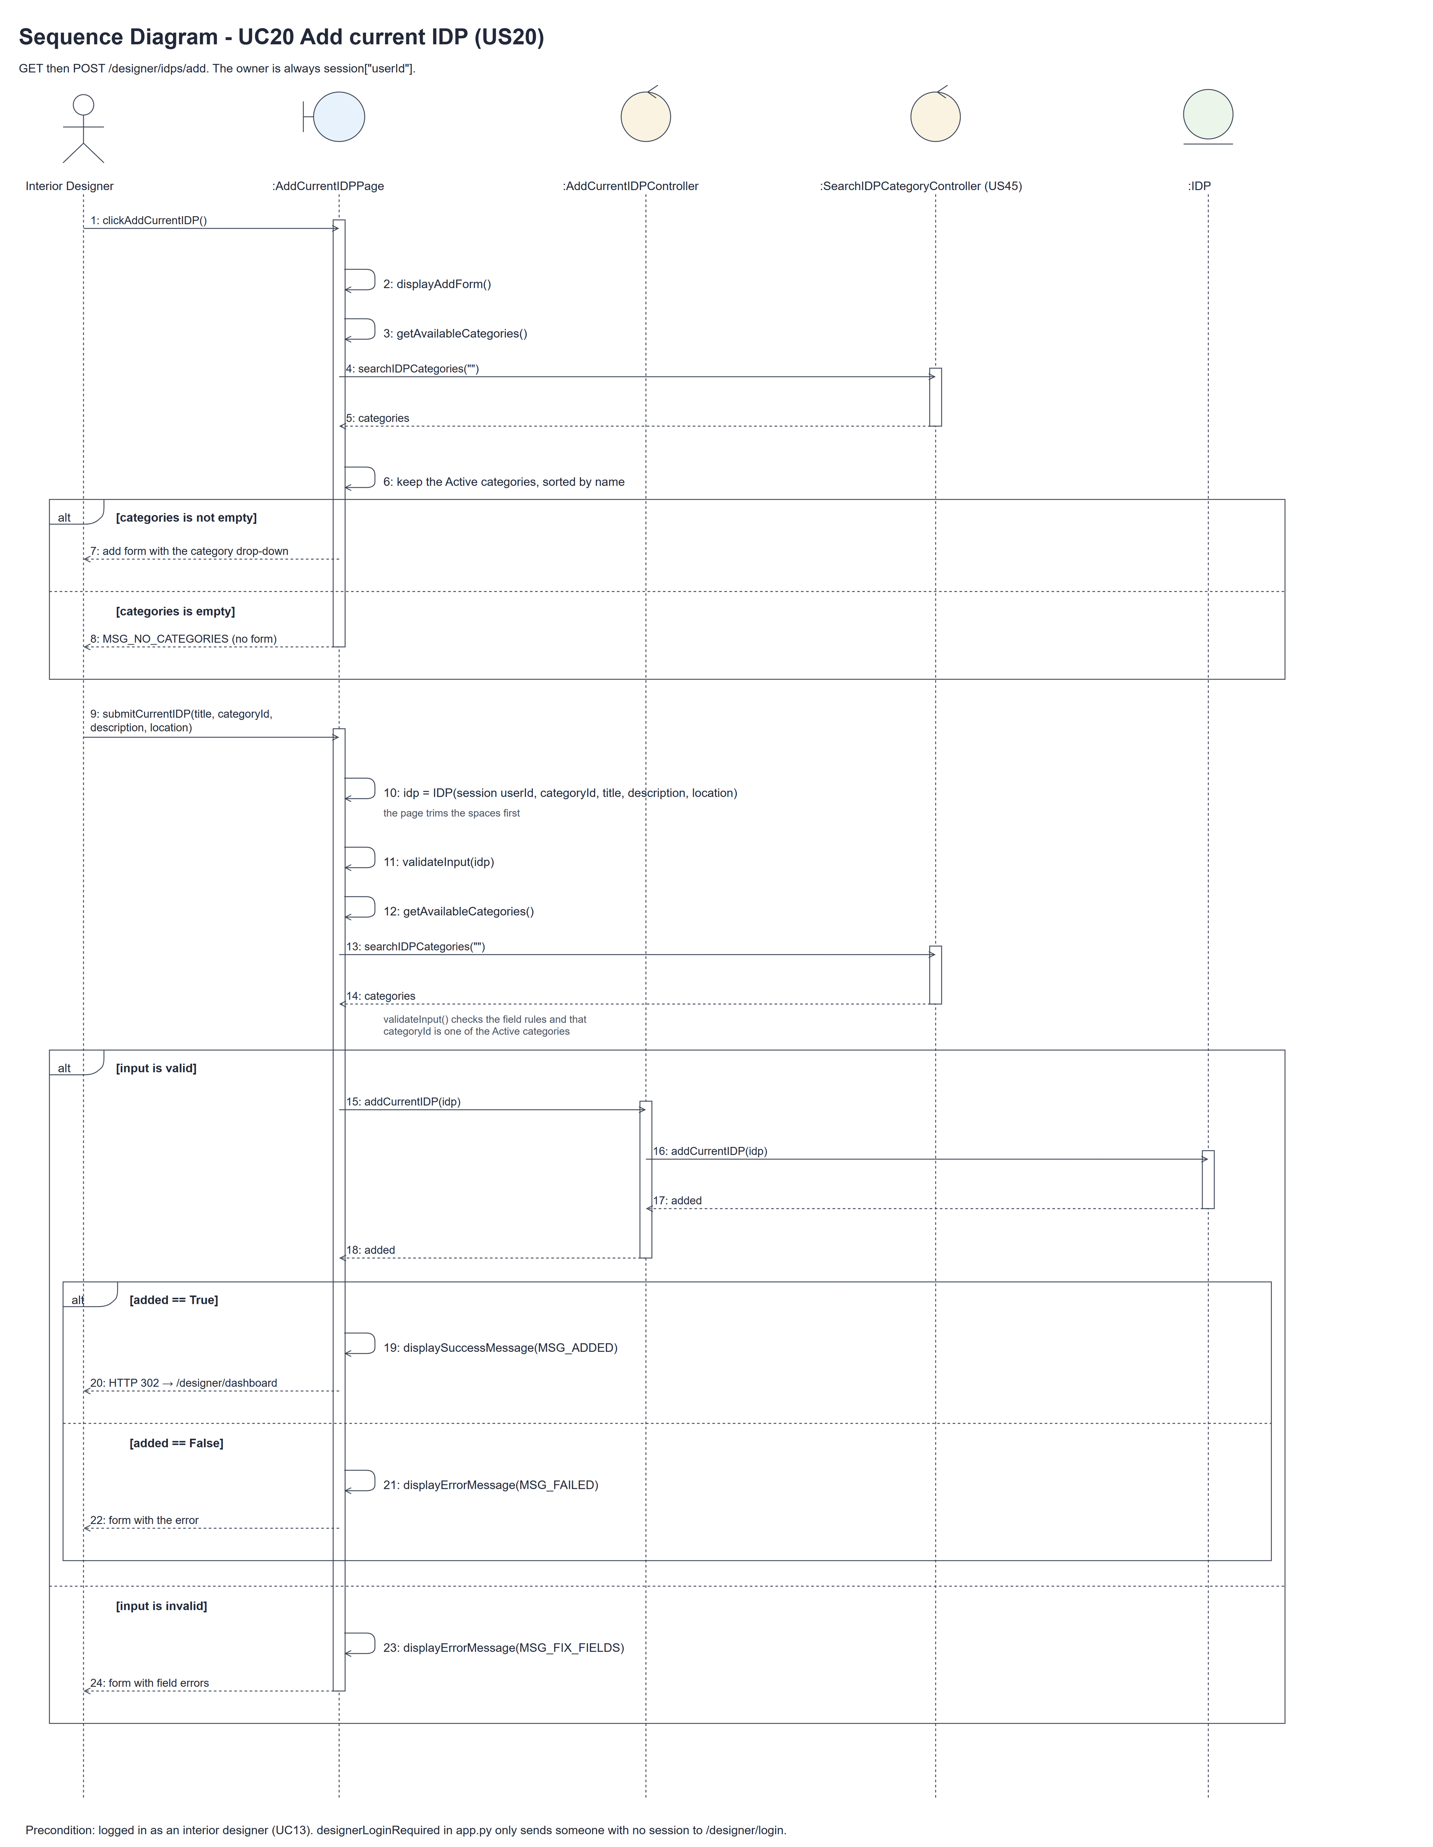
Figure 8: Sequence diagram for UC20 Add current IDP

7. Test cases
Test data used below (same as database/seedData.py and the test files): user profiles User Admin (id 1), Interior Designer (id 2), Customer (id 3) and Platform Manager (id 4), all Active. User accounts admin01 / Admin@123 (User Admin) and cust001 / Cust@123 (Customer). The designer account designer20 / Design@123 (Tengku Uda Designer, Interior Designer profile) is made first with UC8. IDP categories are made with UC41 (e.g. Kitchen, Bedroom). IDP data: "Tampines HDB kitchen", "Open-concept kitchen, carpentry stage.", Kitchen, Tampines.

7a. System test cases (black box)
Equivalence partitioning and boundary value analysis were used to pick the test data. Fill in "Actual result" and "Pass/Fail" after running each test.
Test ID | Scenario | Prerequisites | Test steps | Test data | Expected result | Actual result | Pass / Fail
TC20.1 | Add a current IDP | Logged in as designer20. Kitchen is Active. | 1. Click "Add current IDP"  2. Fill in the form  3. Click "Add current IDP" | IDP data above | Dashboard with "Current IDP added successfully".
TC20.2 | Location is optional | As TC20.1. | 1. Leave Location empty  2. Submit | No location | Saved.
TC20.3 | Required fields missing | As TC20.1. | 1. Leave title and description empty  2. Submit | - | "Please fix the highlighted fields" and "This field is required" under both. Nothing saved.
TC20.4 | Title too short (boundary) | As TC20.1. | 1. Enter the title  2. Submit | "Ab" (2 chars) | "Title must be 3-100 characters". The description is kept.
TC20.5 | No category chosen | As TC20.1. | 1. Leave the category on "-- Choose a category --"  2. Submit | - | "Choose an available category".
TC20.6 | Only Active categories offered | Kitchen Suspended, Bedroom Active. | 1. Open the form | - | The drop-down has Bedroom, not Kitchen.
TC20.7 | No categories yet | No IDP categories. | 1. Open the form | - | "No IDP categories are available yet. Please try again later" and no form.
TC20.8 | Manager sees the IDP | TC20.1 done. | 1. Log in as a Platform Manager  2. View Kitchen | - | "Tampines HDB kitchen" is listed.
TC20.9 | Not logged in | Not logged in. | 1. Open /designer/idps/add | - | The designer login page is shown.

7b. Unit test cases (for TDD)
These are written before the code (test-driven development) and run with pytest. They cover normal inputs, abnormal inputs and boundary values. Each one matches a test function in tests/test_us20_addCurrentIDP.py (UT20.n = test_ut20_n_...).
Test ID | Class and method | Input / setup | Expected output | Type | Pass / Fail
UT20.1 | AddCurrentIDPController.addCurrentIDP() | designer20, valid IDP | True. Saved as Current and Active, owned by designer20 | Normal | Pass
UT20.2 | AddCurrentIDPController.addCurrentIDP() | Category suspended before saving | False. Nothing saved | Abnormal | Pass
UT20.3 | AddCurrentIDPController.addCurrentIDP() | Unknown owner 9999 | Returns false | Abnormal | Pass
UT20.4 | AddCurrentIDPController.addCurrentIDP() | Unknown categoryId 9999 | False. Nothing saved | Abnormal | Pass
UT20.6 | AddCurrentIDPPage.validateInput() | Valid IDP | True. No field errors | Normal | Pass
UT20.7 | AddCurrentIDPPage.validateInput() | Blank title and description | "This field is required" for both | Abnormal | Pass
UT20.8 | AddCurrentIDPPage.validateInput() | Title "Ab" | "Title must be 3-100 characters" | Boundary | Pass
UT20.9 | AddCurrentIDPPage.validateInput() | 101-char title, 201-char location | "Maximum 100 characters", "Maximum 200 characters" | Boundary | Pass
UT20.10 | AddCurrentIDPPage.validateInput() | categoryId None | "Choose an available category" | Abnormal | Pass
UT20.11 | AddCurrentIDPPage.validateInput() | Suspended Kitchen, then categoryId 9999 | categoryId error both times | Abnormal | Pass
UT20.12 | AddCurrentIDPPage.validateInput() | Empty location | Returns true | Boundary | Pass
UT20.13 | AddCurrentIDPPage.getAvailableCategories() | Kitchen, Bedroom, Office (Suspended) | [Bedroom, Kitchen] (Active, by name) | Normal | Pass
UT20.16 | Designer dashboard | designer20 opens it | "Add current IDP" link to /designer/idps/add | Normal | Pass
UT20.17 | AddCurrentIDPPage.clickAddCurrentIDP() | GET the form, Kitchen Active | Form with all four fields and Kitchen | Normal | Pass
UT20.18 | AddCurrentIDPPage.displayAddForm() | No categories | "No IDP categories are available yet". No form | Boundary | Pass
UT20.19 | AddCurrentIDPPage.submitCurrentIDP() | Valid data | Redirect to dashboard with "Current IDP added successfully" | Normal | Pass
UT20.20 | AddCurrentIDPPage.submitCurrentIDP() | Title "Ab" | Field errors shown, description kept, nothing saved | Abnormal | Pass
UT20.21 | AddCurrentIDPPage.submitCurrentIDP() | Forged designerId=1 in the form | Owner is still designer20 | Abnormal | Pass
UT20.22 | /designer/idps/add (designerLoginRequired) | Not logged in | Redirects to /designer/login | Abnormal | Pass
UT20.23 | AddCurrentIDPPage.submitCurrentIDP() | Title and location with spaces around | Saved trimmed | Boundary | Pass
UT20.24 | US20 + US42 together | Designer adds an IDP, manager views Kitchen | IDP shown under Kitchen | Normal | Pass

